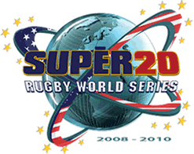
ve

HOST CITIES:

PHILADELPHIA PENSYLVANIA

VILLANOVA STADIUM

CAPACITY 12500

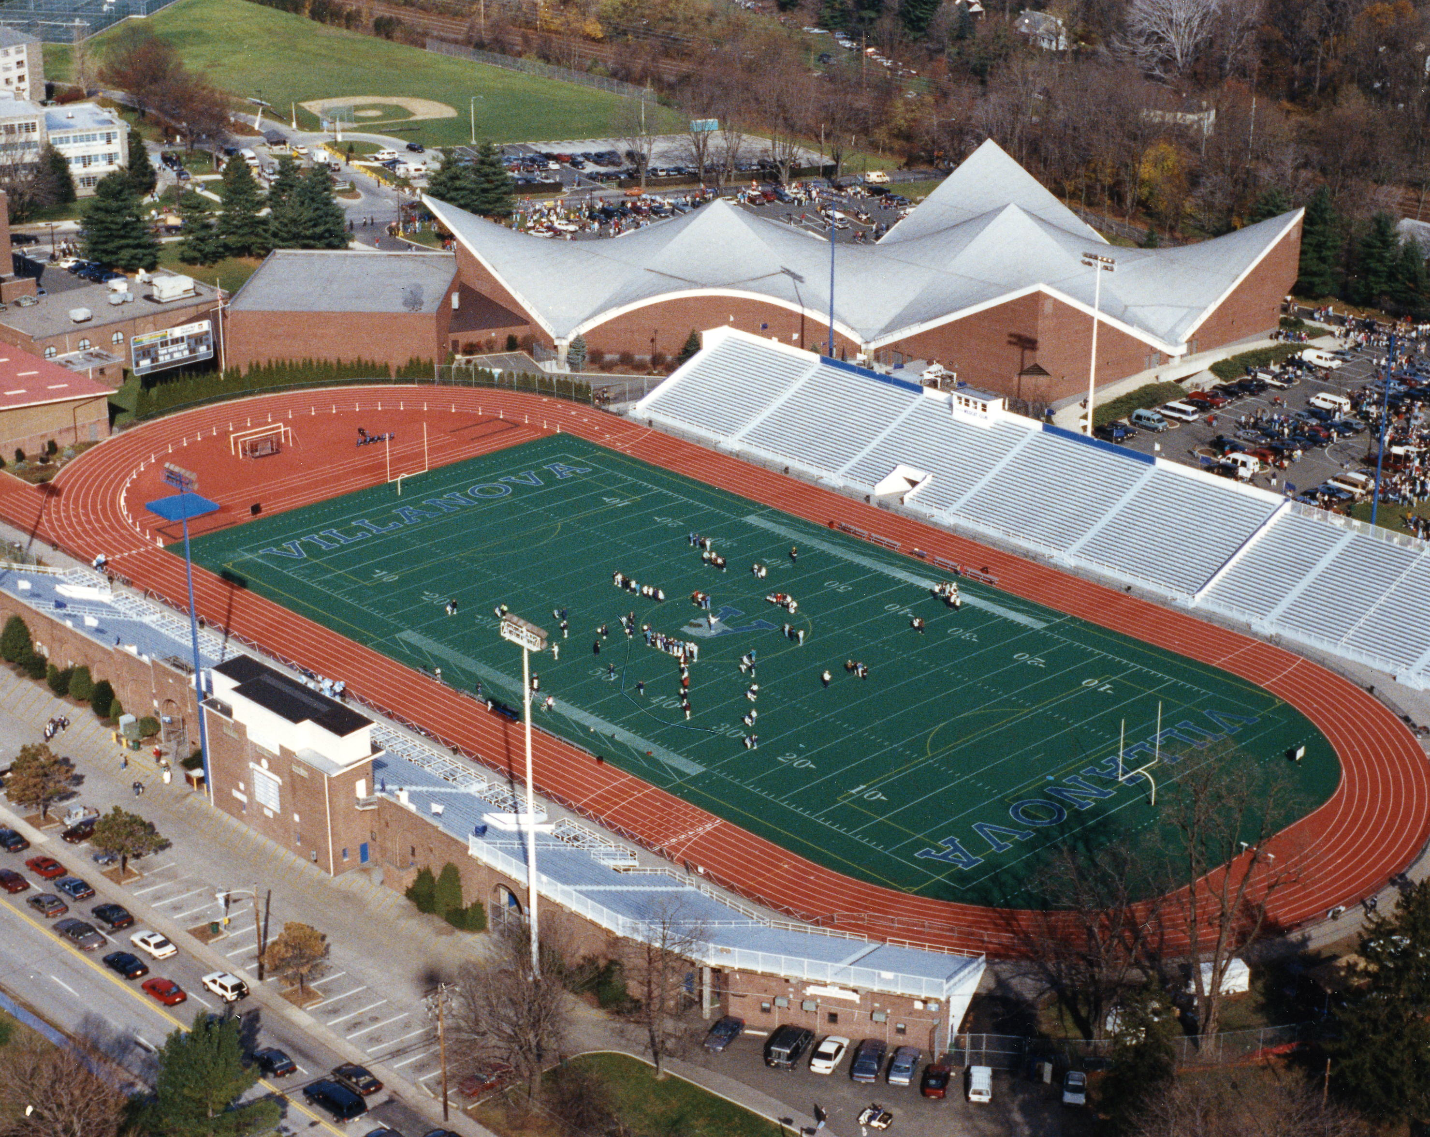

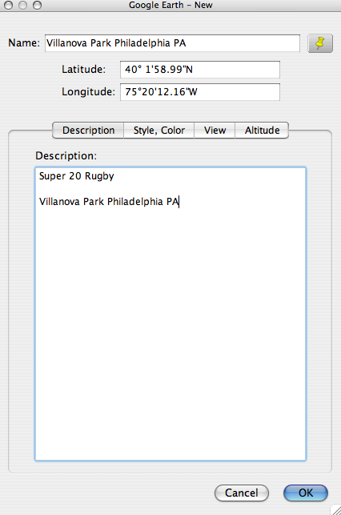

HOST CITY:

ST. LOUIS MICHIGAN

ANHEUSER BUSCH COMPLEX

CAPACITY: 8000
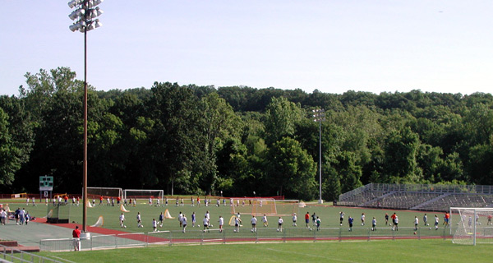

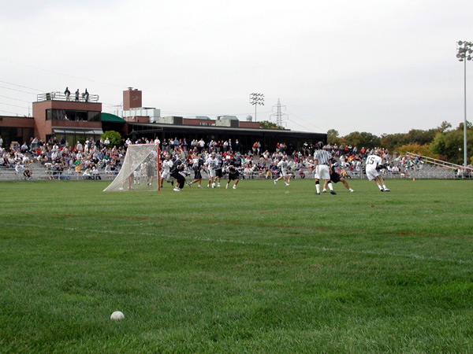

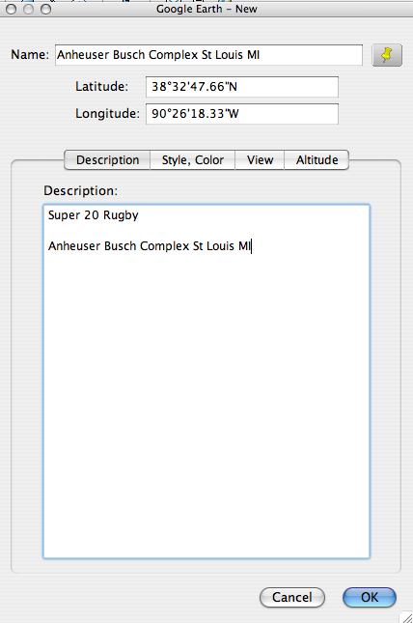

HOST CITY:

CHARLOTTE NORTH CAROLINE

MEMORIAL STADIUM

CAPACITY: 24000

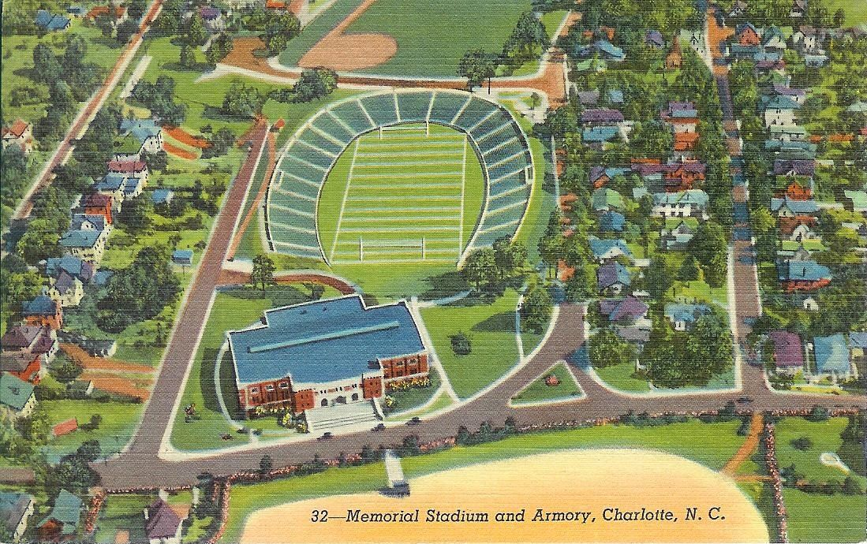

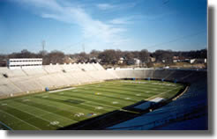

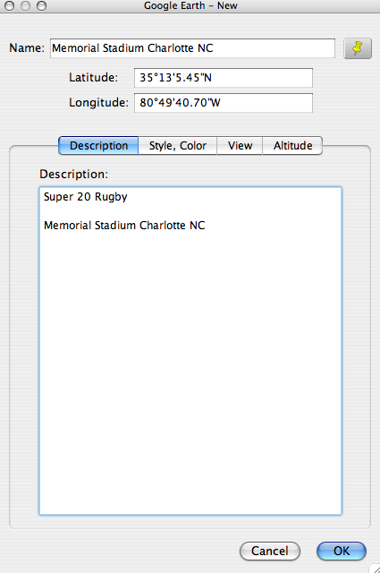

HOST CITY:

SAN FRANCISCO
BUCK SHAW STADIUM
CAPACITY: 10000

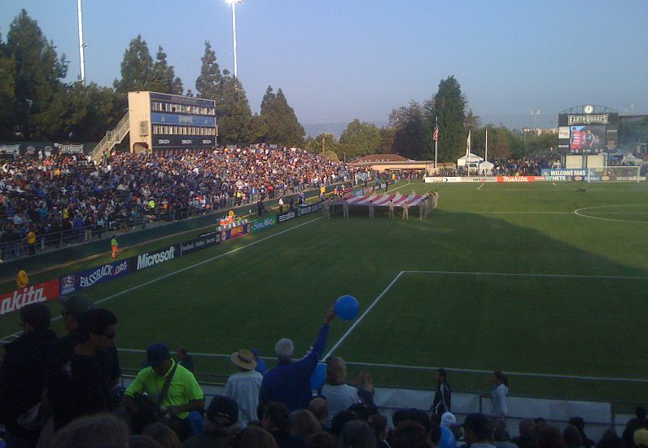

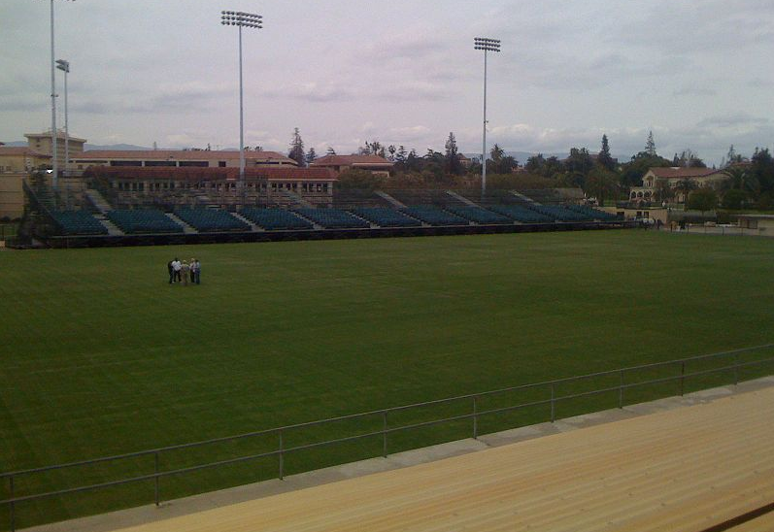

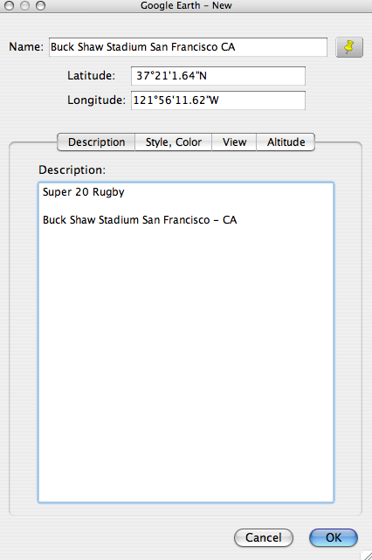

HOST CITY:

BOSTON MASSACUSETTS

WHITE STADIUM FRANKLIN PARK

CAPACITY: 10000

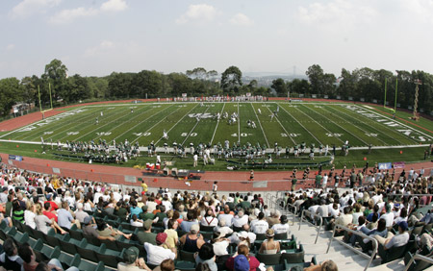
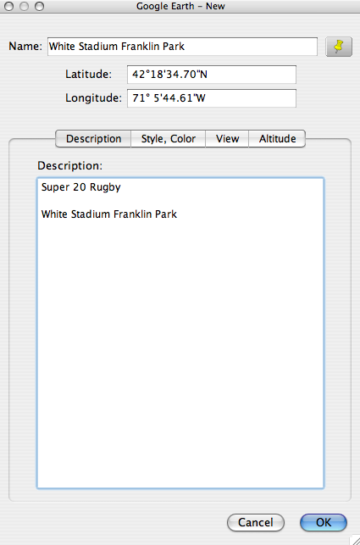

HOST CITY:

MIAMI

CENTRAL BROWARD REGIONAL STADIUM:

CAPACITY: 20000
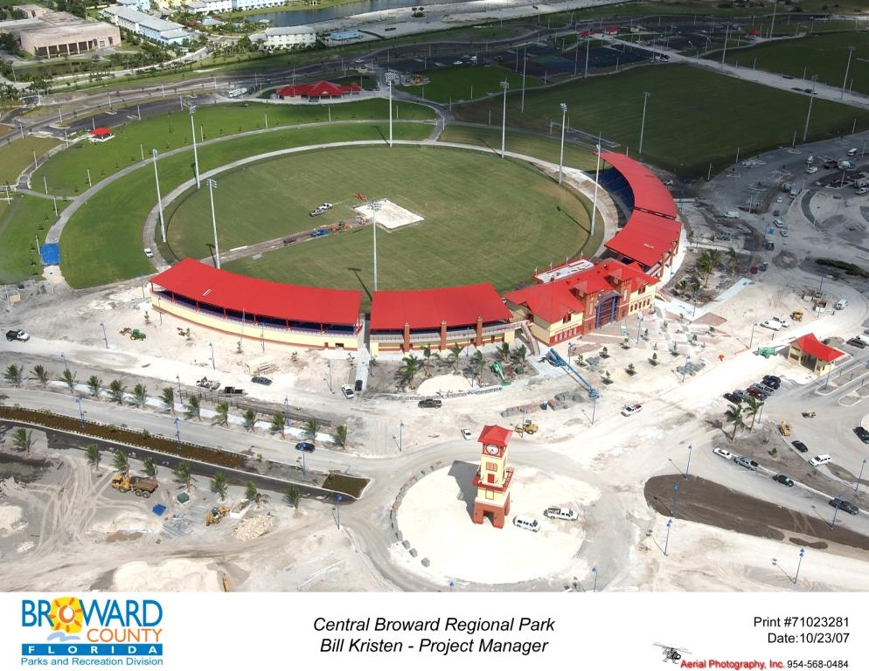

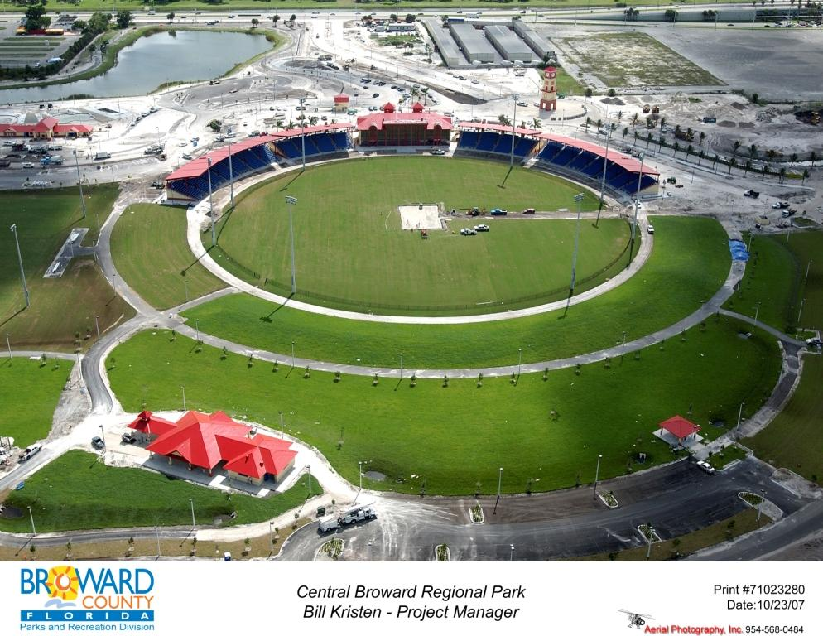

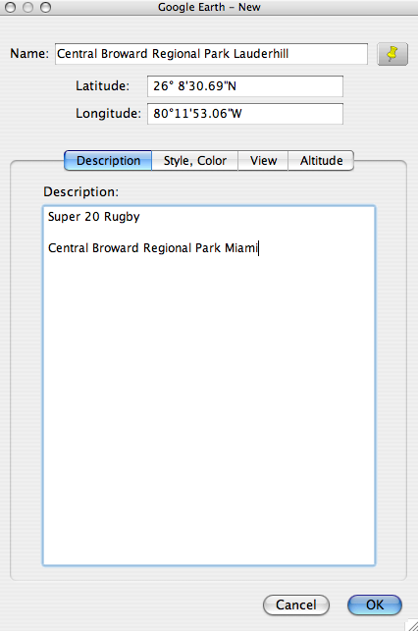

HOST CITY:

CHICAGO ILLONOIS

TOYOTA PARK

CAPACITY: 28000
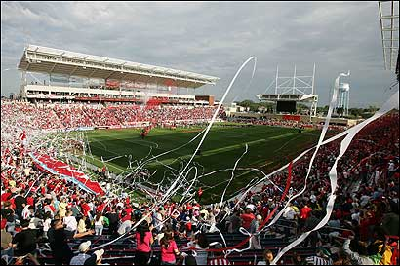

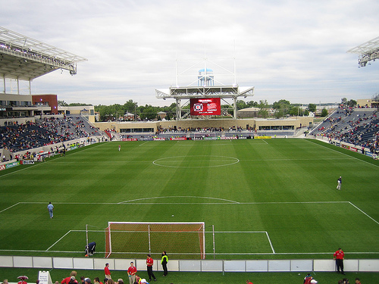

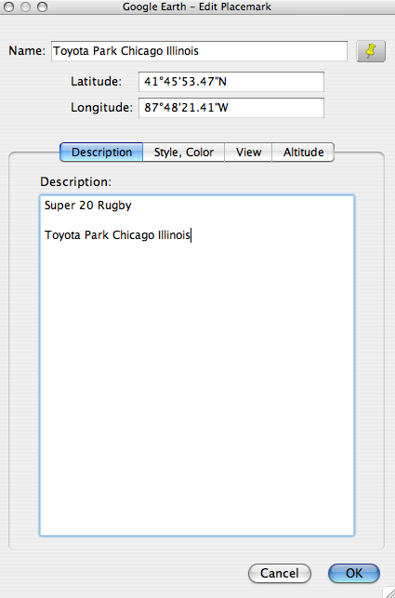

HOST CITY:

NEW YORK

PAETEC PARK ROCHESTER

